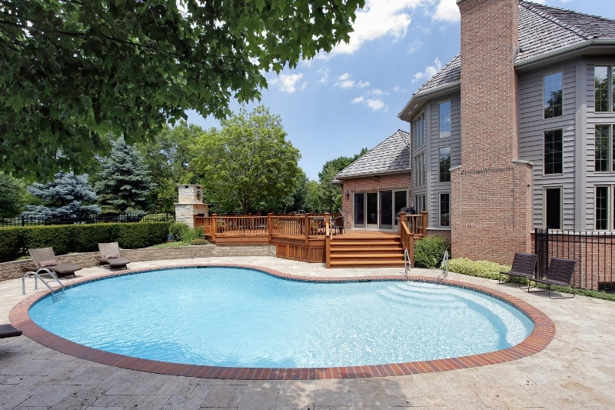

Should I Get a Pool? Pros and Cons
- August 9, 2022

- Seth Raddue

- Home Improvement, Real Estate Tips
As summer temperatures reach record highs in many parts of the United States, homeowners are looking for ways to keep cool and have fun. Installing a pool sounds like a great idea, but there are things you should know before you take the big plunge.

Cost of A Pool
It should come as no surprise that owning a pool can be expensive. Not only do you need to pay to prep your yard and install the pool structure, but you will also need to fill it with water, have a way to heat it, and pay to keep it up.
Pool chemicals can be expensive but necessary to maintain a safe environment for swimmers. Saltwater pools are another option that can be less expensive to maintain. You will still need to add salt periodically and make sure that things like the filter, tiles, and liner are all in good working order.

Pool Setup
If you have space in your yard for an in-ground pool, they look the best, last the longest, and can be a useful selling feature. Keep in mind that not everyone will want a swimming pool and it also depends on what is typical in your area. Working with a knowledgeable Realtor can help you determine when and if adding a swimming pool with increasing your home’s value.
Above-ground and temporary pools can be a good option for those who just want something for a single season. Just remember that the grass underneath the pool will die if you leave it in one place for more than just a few hours. Even small child pools can quickly wilt or kill the grass underneath. Adding a liner underneath can help prevent rocks and sticks from puncturing your pool or making your swimming experience uncomfortable.

